
Masai Sliding Step Fitting
Guide and Maintenance Tips

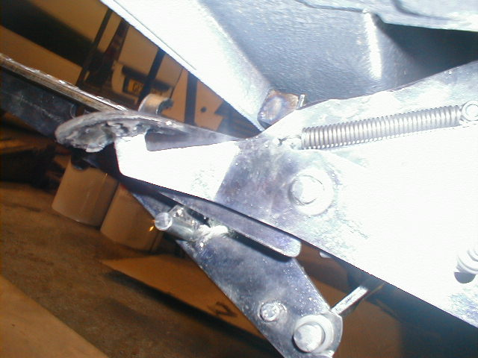
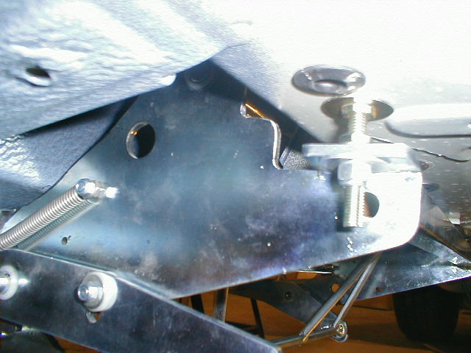

www.masai.co

+44(0)1283-712328

Masai Sliding Step Maintenance Tips
Thank you for purchasing the Masai Sliding Step.
The Masai side sliding step is manufactured to a very high standard to provide a reliable service for its users. However like all mechanical moving items, it does require simple maintenance. We recommend the following :
- All moving parts should be washed regularly by jet wash as it is exposed to heavy road conditions. This process should be done every 4 weeks on a regular basis.
- All moving parts should be lubricated with silicon spray at least every 4 weeks especially in winter months.
- It is recommended that the step is protected by mud guard/flaps if it is fitted near the front wheels of a vehicle.

